

American International University-Bangladesh (AIUB)

**Software Project 1**

**Online marketplace for pharmacy and emergency ambulance service providers**

**Submitted By:**

| 16-32611-3 | Mohammed Shahadat Hossain |
| --- | --- |

**Department of Computer Science**

**Faculty of Science & Technology**

**American International University - Bangladesh**

**October, 2020**

| **Declaration** |
| --- |

We declare that this project is our original work. No part of this has been submitted elsewhere partially or fully for the award of any other degree. Any material reproduced in this project has been properly acknowledged.

We declare that this project does not contain any content that discloses the secrets of any organization or related parties. American International University-Bangladesh (AIUB) will not be held liable for any such activity, as for the project presented as our original work.



| _______________________________  **Mohammed Shahadat Hossain**  16-32611-3  SE |  |
| --- | --- |
|  |  |

| **Approval** |
| --- |

The thesis titled “Online Marketplace for Pharmacy and Emergency Ambulance Service Providers” has been submitted to the following respected members of the board of examiners of the Department of Computer Science in partial fulfillment of the requirements for the degree of Bachelor of Science in Computer Science on (date of defense) and has been accepted as satisfactory.

| **-----------------------------------------------**  **Raihan Uddin Ahmed**  Assistant Professor and Supervisor  Department of Computer Science  American International University-Bangladesh | **--------------------------------------------**  **Mohaimen-Bin-Noor**  Lecturer and External  Department of Computer Science  American International University-Bangladesh |
| --- | --- |
| ……………………………………  **Dr. Md. Abdullah-Al-Jubair**  Assistant Professor & External  Department of Computer Science  American International University-Bangladesh | -----------------------------------------  **Aneem Al Ahasan Rupai**  Lecturer & External  Department of Computer Science  American International University-Bangladesh |
| ----------------------------------------------  **Dr. Mahbubul Syeed** Head (Undergraduate Program) Department of Computer Science American International University-Bangladesh | **--------------------------------------------**  **Professor Dr. Tafazzal Hossain** Dean Faculty of Science & Information Technology American International University-Bangladesh |
| **-----------------------------------------------------**  **Dr. Carmen Z. Lamagna**  Vice Chancellor  American International University-Bangladesh | |

|  |  |
| --- | --- |
|  | |

| **Acknowledgment** |
| --- |

This Project is our cordial effort and our supervisor’s initiative and constant motivation. But First, we would like to be grateful to the Almighty Allah, who gave us the effort to work on this project for the last semester. Special thanks go to our honorable supervisor faculty member Raihan Uddin Ahmed, American International University-Bangladesh [AIUB] for this enormous support, inspiration, and helpful criticism. His excellent supervision and constant support make this project possible. We are very grateful to him for allowing us to work with him. We also convey our thanks to our honorable Vice Chancellor, Dr. Carmen Z. Lamagna, our Dean, Prof. Dr. Tafazzal Hossain, our Associate Dean, Mashiour Rahman, our Director, Dr. Dip Nandi, and our Head of Department, Dr. Mahbubul Syeed for their constant motivation and support.

Last but not least we thank our respectable parents for educating us with aspects from both arts and sciences, for their unconditional support and encouragement to pursue our interests, even when interests went out of boundary.

**TABLE OF CONTENTS**

Declaration 2

Approval 3

Acknowledgment 4

**CHAPTER 1** **7**

PROJECT INITIATION 7

Online Marketplace for Pharmacies and Emergency Service Providers 7

Background of the problem 7

The objective of this project 7

1.4.1 Details of previous works 8

1.4.2 Summary of the issue 8

**CHAPTER 2** **8**

REQUIREMENTS ELICITATION 8

2.1 Product Perspective: 9

2.2 User Classes and Characteristics: 9

2.3 Operating Environment: 9

2.4 Design And Implementation Constraint: 10

10

**CHAPTER 3** **10**

REQUIREMENTS SPECIFICATION 10

3.1 Business Requirement 10

3.2 System Features: 10

Use stories 13

**CHAPTER 4** **16**

SOFTWARE DESIGN SPECIFICATION 16

4.1 Use Case Diagram 16

4.2 Class Diagram 17

4.3 ER Diagram 19

4.4 Schema Diagram // phone 20

4.5 User Interface Design 21

4.6 Mockup Testing Review 31

**CHAPTER 5** **34**

REQUIREMENTS VALIDATION 34

5.1 Formal review (inspection process) 34

**CHAPTER 6** **35**

SOFTWARE PROJECT MANAGEMENT PLAN 35

6.1 Project Estimation 35

6.3 Project Scheduling 37

6.4. Risk Assessment 37

**CHAPTER 7** **38**

CONCLUSION & REFERENCES 38

7.1 Conclusion 38

7.2 References: 38

**APPENDIX**

**LIST OF FIGURES**

Figure 1: System Login Interface 2

Figure 2: User Registration

**LIST OF TABLES**

Table 1: System Login Test Case 2

Table 2: User Registration Test Case

**PROJECT SUMMARY**

The purpose of the project is to develop systems that reduce the stress of buying medicine & finding ambulances whenever needed. In this modern world, people are less concerned about buying medicine online but they are connected through social networks. This project will help people build a good knowledge about online shopping and the benefits of online shopping. This research suggests a web-based application that will provide all the facilities and features to buy medicine without any hassle & search for a location-based emergency ambulance at any time. Payment can be done with cards, online banking, and PayPal through SSL commerce. The final product can be an independent program that can be accessed by people from all over the world.

**Keywords:** Online Marketplace, online Pharmacies, Emergency Service Providers, Emergency Ambulance..

# CHAPTER 1

## PROJECT INITIATION

### Online Marketplace for Pharmacies and Emergency Service Providers

The Online marketplace for pharmacy and emergency ambulance service providers aims to make the ordering process and delivery system of medicines much easier and customer-friendly. This online pharmacy has a wide variety of products including baby milk, baby food, baby care products, child care products, dental medicines, diabetic kits and accessories, eye medicines, sanitary products, hygiene products, mother’s care products, birth control products, surgical items, etc. To purchase particular medicines regularly customers can upload and save prescriptions on this website or manually buy the selected items, which is certainly a great benefit for senior citizens. It has a cash-on-delivery option for any location within Dhaka and also has cards, Bkash option. This online pharmacy delivers products from 8 am to 10 pm every day. It can deliver products within one to three hours and take orders up to 9.0 pm for same-day delivery.

Ambulance service will be available for 24 hours.Ambulance will register their ambulance in the system and offer emergency services 24 hours.

### Background of the problem

We all need medicine. Sometimes all of us need emergency medicine and an emergency ambulance. If the situation is not favorable to go outside then need an emergency solution. It is not possible to go outside every time for medicine. There are many reasons behind it. This system will help get rid of this problem.

We need an emergency ambulance for serious patients. But we don’t have enough information for booking or calling ambulances. This system will help get rid of this problem.

### The objective of this project

**1.** **Build a web application to -**

a) Register all pharmacies

b) User registration

c) Make a database for all medicines which is available in the registered pharmacy

d) Make a database for emergency services such as ambulances which contain the phone number of the ambulance service area wise.

**2.** **Build a mobile application -**

a) It will be more user-friendly and much easier

### 1.4.1 Details of previous works

All the previous work is done using different methods and technologies. One of them is a medicine delivery service. They have a search and order system for buying medicine online. They have home care nursing services for those suffering for a long time in bed. They have home physiotherapy services. They have childcare nursing. They have herbal medicine And dental services.

Bangla Meds is one of them. They also deliver medicine online and customers can upload the prescription and then pharmacists select the medicine and confirm an order.

Emedi is a Chittagong-based online medicine store. They provide home delivery all over in Chittagong city. All you have to do is, upload your prescription or add items from their website to order your medicines.

Oshud.com is an online medicine store that offers home delivery in Dhaka. Currently, they are not taking orders through their website..

### 1.4.2 Summary of the issue

We all need medicine. Sometimes all of us need emergency medicine and an emergency ambulance. If the situation is not favorable to go outside then need an emergency solution. It is not possible to go outside every time for medicine. There are many reasons behind it. This system will help get rid of this problem.

We need an emergency ambulance for serious patients. But we don’t have enough information for booking or calling ambulances. This system will help get rid of this problem.

# CHAPTER 2

## REQUIREMENTS ELICITATION

### 2.1 Product Perspective:

Online marketplaces for pharmacies and emergency service providers is a new web-based system that will replace all the other web-based applications that are giving the traditional Online medicine shopping features and will add some new features including emergency ambulance, buy medicine in fully online, smart notification system, payment method also online based etc. There are lots of Online medicine stores on the internet. All of them focus on only online medicine ordering and usually no extra features. It is going to provide an overall system that will try to increase the facility between buying medicine through different categories of medicine equipment. The system will be hosted on the Firebase cloud server which will automatically maintain the database.

### 2.2 User Classes and Characteristics:

Any person who has experience running well-known e-commerce apps on the internet or mobile phone can use my Online Medicine store & emergency service providers without any problem. There are 3 types of users.

**types of users:** Admin (Direct user),

Users (Direct user),

Medicine Seller (Indirect user),

Ambulance Company (Indirect user).

**types of Characteristics:**

**Admin:** Someone, probably from the management/IT department who can view records of all medicine & ambulance, can view records of all orders, cancel & return can authorize medicine & ambulance.

**Users:** Any customers by the organization whose data needs to be maintained. This class of users can only view their records and updates of their information, cancel orders, place orders, Booking an ambulance if necessary.

**Medicine seller:** Users of this class will be solely responsible for supplying all medicine

and checking the medicine data expiry date. They can do inserts/updates and see medicine lists only after a higher authority authorizes them to do so.

**Ambulance Company:** Ambulance companies rent ambulances for emergency ambulance services. Customer can search their location and find location-wise ambulances by searching.

### 2.3 Operating Environment:

1. **Firebase Authentication:** Firebase authentication is going to provide the authentication mechanism for the software which includes sign-up using Google and Facebook, phone number verification, and API endpoints verification.
2. **Firebase Cloud Functions:**  Firebase cloud functions will be used to deploy the NodeJS server and the website.
3. **MongoDB Atlas:** MongoDB Atlas is a cloud service that provides maintained MongoDB instances.

### 2.4 Design And Implementation Constraint:

### 

      1.   **Node JS:** NodeJS is going to be used for the back-end server.

      2.   **Flutter/ React Native:** Flutter /React Native is going to be used to create a

cross-platform mobile application.

      3.   **React JS:** It is going to be used to create the client website.

      4.   **MongoDB:** MongoDB will be used as the database system.

5.  **GraphQL:** GraphQL is going to be used for providing API.

# CHAPTER 3

## REQUIREMENTS SPECIFICATION

### 3.1 Business Requirement

The project focuses on the following business objectives:

1. End-users should be able to use the software with minimum training.
2. End-users should understand the functionalities by seeing the interface. consistency in the design should be understandable for the end-user to interact with the system.
3. User should be able to easily search for any knowledge article and solve problems on their own
4. The search function should be clearly defined within the application, which should be stocked with answers to the most common questions
5. user should be able to give feedback
6. You should browse every page as quickly as possible.
7. Users should be able to access default features that have basic functionalities, note features should be available in the premium version

### 3.2 System Features:

**1. Software Login**

**Functional Requirements:**

1.1 The software shall allow users to login with email and password, Facebook or Google.

Priority Level: High

Precondition: users have signed up in the system.

2. Software Signup

**2. Functional Requirements:**

1.1 The software shall allow users to sign up with email and password, Facebook or Google.

1.2 After the sign-up process by providing login credentials and verification of the email(in case the user did not sign up by Facebook or Gmail) then they need to provide additional information which are user name, mobile number, and address.

**Priority**: High

**Precondition**: users have a valid email ID Facebook account or Google account.

**3. Online medicine stores and emergency service provider**

**Functional Requirements:**

1.1 The software shall allow users to buy medicine & medicine equipment online. And also allows users to search for ambulances location-wise.

1.2 The information needed to place an order in this system:

1. Name of the users

2. Shipping address of the users

3. The email address of the users(must)

4. phone number of the users (must)

5. Photo of the prescription. In case a photo is not provided, then users can manually select their order items.

6. items

7. Quantity

8. Payment method

1.3 Users can see their selected items which items are ordered & also see bill info in their email inboxes.

1.4 Users can modify orders, and cancel orders before delivery.

**Priority**: High

**Precondition**: The user has an account in the software.

4. **Scheduling: offer subscription package**

**Functional Requirement:**

1.1 User can schedule different types of events in the system which are

1. Searching ambulances in their preferred location.

2. Collect ambulance info from this website and call them directly to book.

**Priority**: High

**Precondition**: users must have an internet connection for searching and Must have an account.

5. **Notification System**

**Functional Requirement:**

1.1 The System can provide users with the below types of events:

1. Call ambulance

2. Notify the nearest ambulance car driver

3. Order medicine

4. Modify medicine (if an order is done then it can modify)

5. Notify admin and then admin notify the pharmacy agent if a person is ordering something in a valid way

6. Give search suggestions when users buy medicine

8. Suggest a time for users to receive orders.

9. Notify if the user's order is ready to deliver before delivery order

10. If an order is confirmed by a nearby then the admin sees the notification

**Priority**: High

**Precondition**: The user must have an active account.

**3.3 Non-Functional Requirement**

**3.3.1 System Performance:**

1. The client-side application needs to be fast and responsive
2. The server needs to have good performance and low latency so that it can serve the client-side request fast.

**3.3.2 System Security:**

1. The API endpoints need to be secure using a token-based system.
2. Server-side backend needs to prevent cross-site scripting, SQL injection, and DDoS attack.
3. The server needs to be secured using ssh keys.
4. SSL is mandatory.

**3.3.3 Safety Requirements**

The Application Server and Database server must be in a safe environment to guard them against any physical damage either caused by human factors or natural disasters**.**

Standards for developing web applications.

**3.3.4 Usability**

Usability of the software will be determined from conversations and interviews with the user base. Furthermore, testing will be done to ensure fulfillment of usability criteria.

**3.3.5 Availability**

System must have 99% uptime. Any downtime should be due to maintenance or emergencies arising from natural or man-made disasters.

### Use stories

**Table 1: System Login**

| Use Case Name | Login to system | Use Case Type |
| --- | --- | --- |
| Use Case ID | UC_1 | Functional Requirement |
| Priority | High |
| Primary Business Actor | User | |
| Other Interested Stakeholders | None | |
| Description | This use case describes how to enter into the System. By giving some details like User name, password. the system can check the validation and enter it into the system. Users can log into the system by Facebook or Google account | |
| Precondition | The user must be valid. | |
| Trigger | The use case is initiated when a user tries to enter the system. | |
| Typical Course of Events | Step 1: The user inputs a username, password Facebook account, or Google account.  Step 2: By clicking on login a validation process is run by the system  Step 3: If the username and password are matched the user can go to the home page of my family tree. | |
| Conclusion | The use case concludes when the user gets a login confirmation message from the system. | |

**Table 2: System sign up**

| Use Case Name | signup to system | Use Case Type |
| --- | --- | --- |
| Use Case ID | UC_2 | Functional Requirement |
| Priority | High |
| Primary Business Actor | User | |
| Other Interested Stakeholders | None | |
| Description | This use case describes how to register into the System. By giving some details like User name, password, email, mobile no, address, or Facebook or Google account. The system checks if the username and password are unique then the user is allowed to log in. | |
| Precondition | If the user does not have any account or the user must have a valid Facebook or Google account. | |
| Trigger | The use case is initiated when a user registers into the system. | |
| Typical Course of Events | Step 1: The user inputs username, password, email, mobile no, and address Facebook account or Google account.  Step 2: By clicking on signup a validation process is run by the system  Step 3: If the username and password or Facebook or Google account is unique then the user can go to the login page to enter the system. | |
| Conclusion | The use case concludes when the user gets a confirmation message of successful registration in the system. | |

**Table 3: Medicine order and Ambulance booking**

| Use Case Name | Medicine order and ambulance booking | Use Case Type |
| --- | --- | --- |
| Use Case ID | UC_3 | Functional Requirement |
| Priority | High |
| Primary Business Actor | User | |
| Other Interested Stakeholders | None | |
| Description | This use case describes how customers order medicine and book an ambulance. By giving some information to complete their order and not booking an ambulance like name, email, phone no, and location. | |
| Precondition | the user must have a valid account in the software. | |
| Trigger | The use case is initiated when a user enters to order. | |
| Typical Course of Events | Step 1:The user inputs location, phone number, email address, and prescription  Step 2: By clicking on the order now fill in the form to place the all information and select the order place or booking ambulance and get the payment method to the system  step 3: user can modify his/her order and booking an ambulance. | |
| Conclusion | The use case concludes when the user places the order and gets the payment option in the system. | |

**Table 4: Scheduling**

| Use Case Name | Scheduling | Use Case Type |
| --- | --- | --- |
| Use Case ID | UC_4 | Functional Requirement |
| Priority | Medium |
| Primary Business Actor | User | |
| Other Interested Stakeholders | None | |
| Description | This use case describes when the user orders a monthly subscription. The system allows users to get their day, week subscription, or monthly. Users can change it according to their needs. | |
| Precondition | the user must have at least one subscription choice only. | |
| Trigger | The use case is initiated when a user selects one. | |
| Typical Course of Events | Step 1: the user adds their medicine to to order  Step 2: The system creates a schedule if they want to get a subscription then select  Step 3: users can change the subscription in the scheduling. | |
| Conclusion | The use case concludes when the user selects their subscriptions. the system says which one and the user selects the option. The system notifies the scheduler. | |

**Table 5: System notification**

| Use Case Name | Notification | Use Case Type |
| --- | --- | --- |
| Use Case ID | UC_5 | Functional Requirement |
| Priority | Medium |
| Primary Business Actor | User | |
| Other Interested Stakeholders | None | |
| Description | This use case describes how users can get notification when any activity changes in the system or by themselves. System notification for some activities like system changes, call time, delivery, locations, if anyone needs an ambulance, if anyone is unreachable, etc. | |
| Precondition | The user must have an active account. | |
| Trigger | The use case is initiated when a user creates an account. | |
| Typical Course of Events | Step 1: the user creates their account in the software.  Step 2: The system automatically notifies the user from time to time when any changes appear in the system. | |
| Conclusion | The use case concludes when the user gets a notification of any activity. | |

# 

# CHAPTER 4

## SOFTWARE DESIGN SPECIFICATION

### 4.1 Use Case Diagram

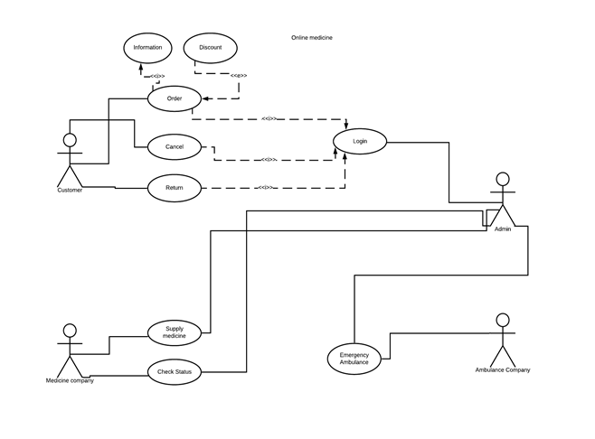

Figure 01: Use Case Diagram...

### 4.2 Activity Diagram

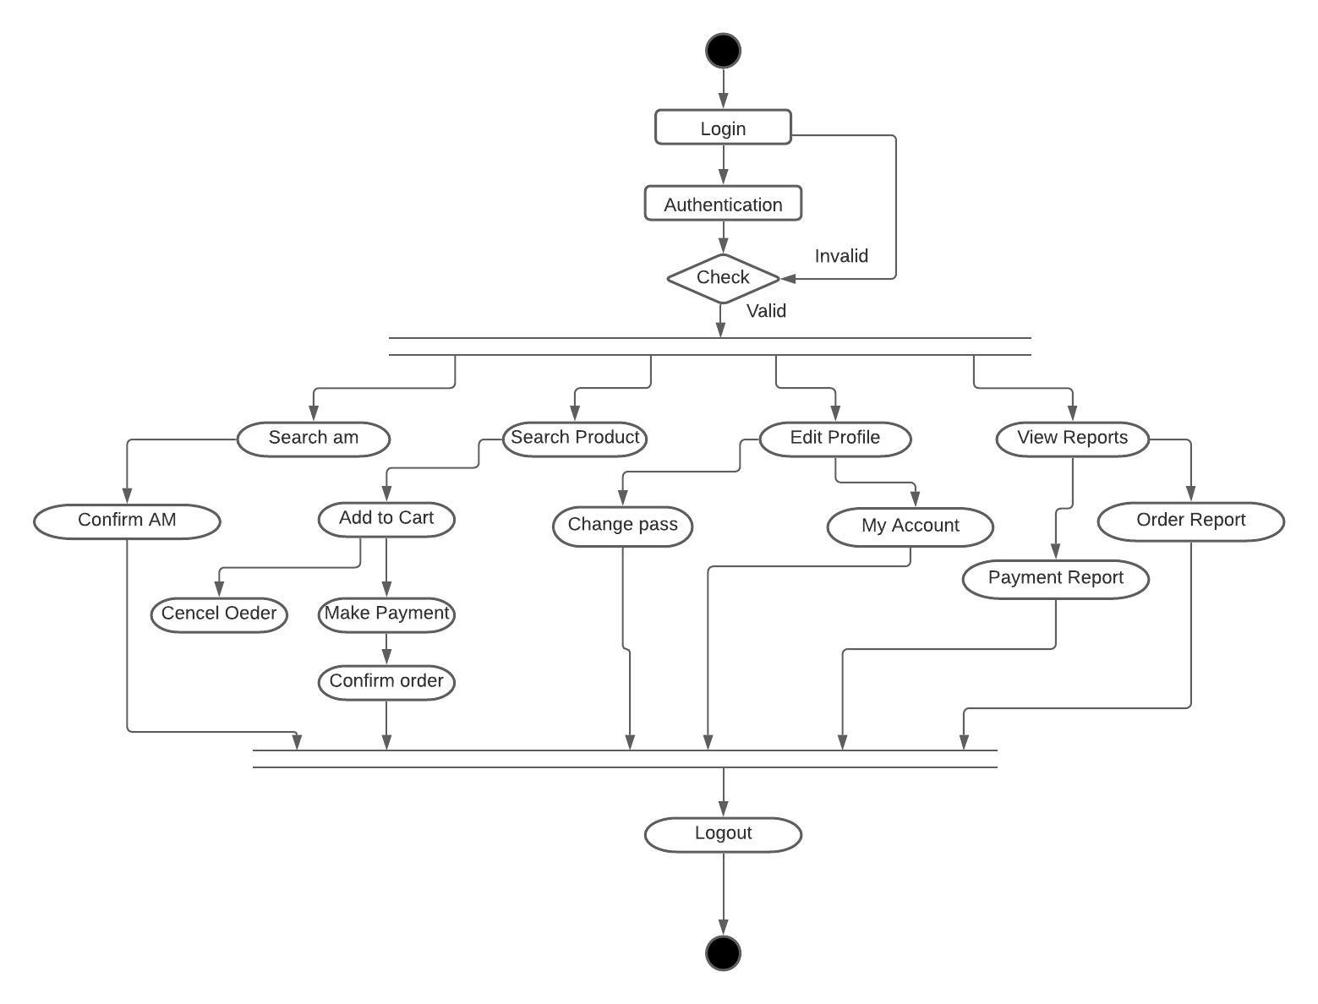

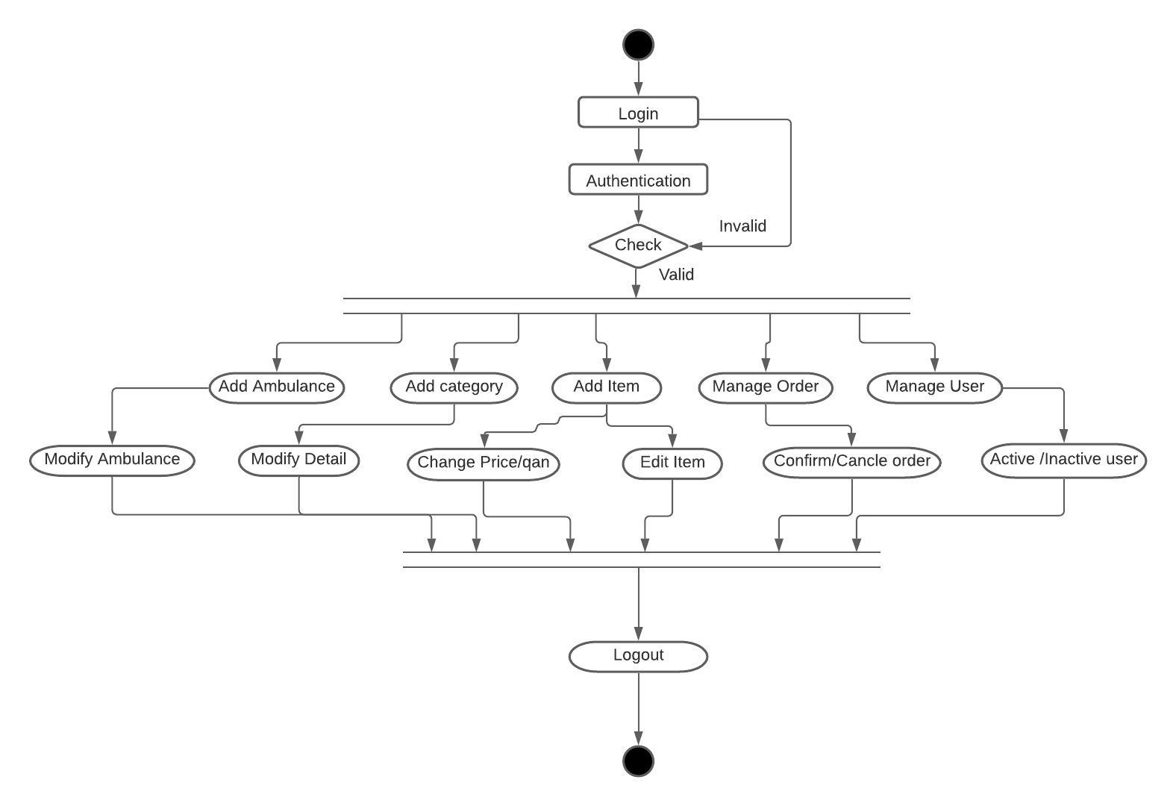

Figure 02: Activity Diagram

### 4.4 Class Diagram

### 

‌‌‌‌‌

Figure 03:Class Diagram

### 4.3 ER Diagram

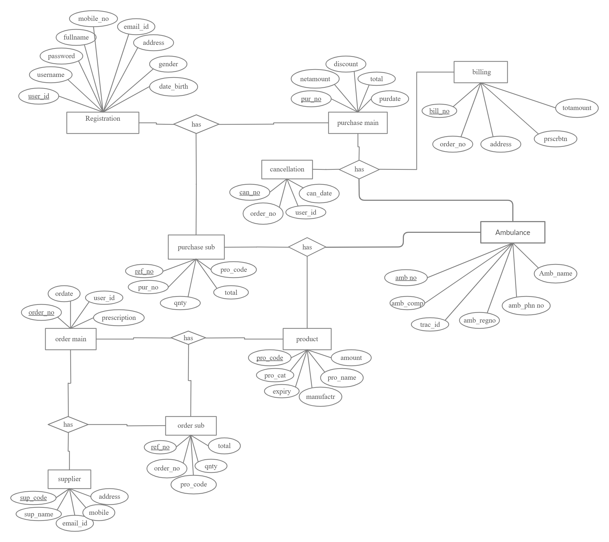

Figure 04: ER Diagram

### 4.4 Schema Diagram // phone

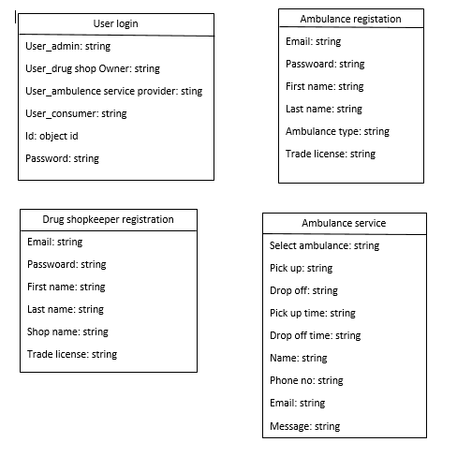

Figure 05: Schema Diagram

### 

### 

### 

### 

### 

### 

### 

### 

### 

### 

### 

### 

### 

### 

### 

### 4.5 User Interface Design

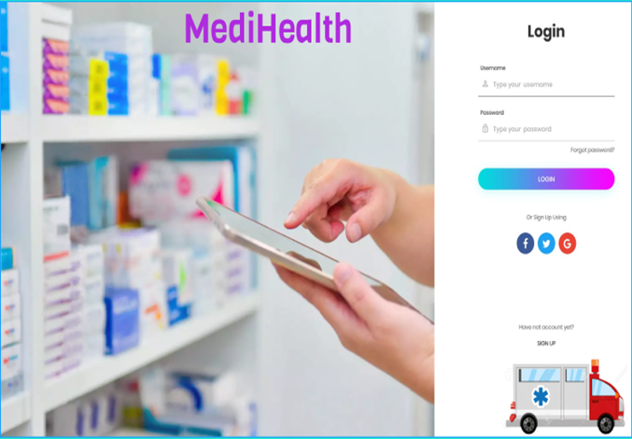

**Figure 06: Sign Up Page**

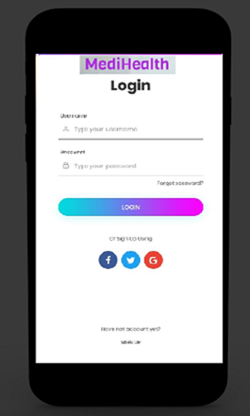

Figure 07: Sign Up Page (Mobile Mode)

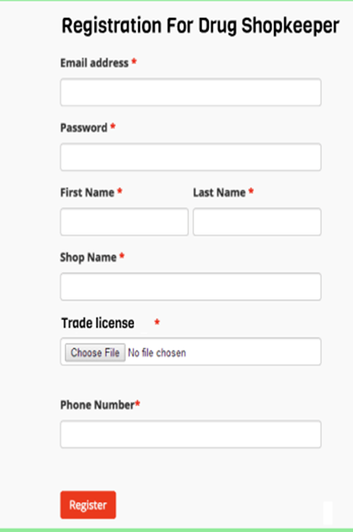

Figure 08: Registration Page for Drug Shopkeeper.

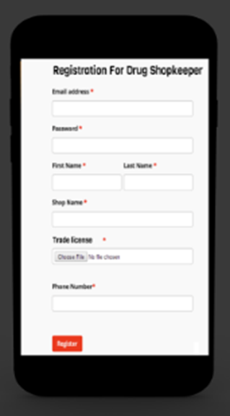

Figure 09: Registration Page for Drug Shopkeeper (Mobile version)

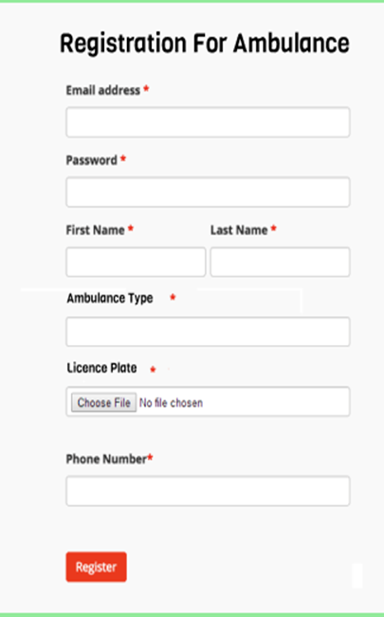

Figure 10: Registration Page for Ambulance

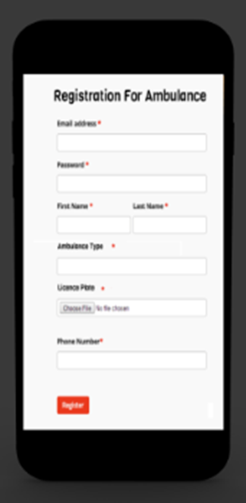

Figure 11: Registration Page for Ambulance (Mobile Version)

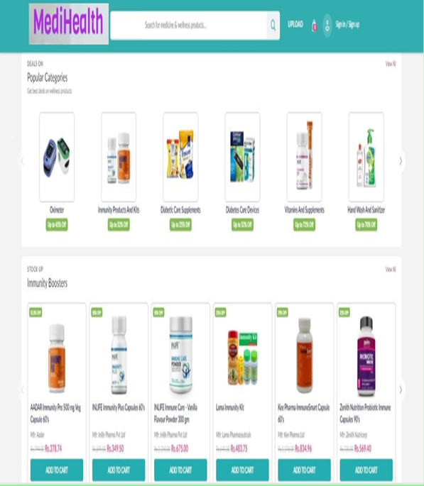

Figure 12: Home page of MediHealth

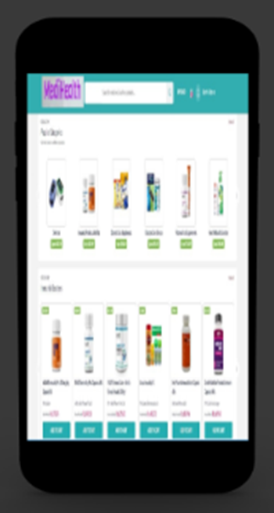

Figure 13: Home page of MediHealth (Mobile Health)

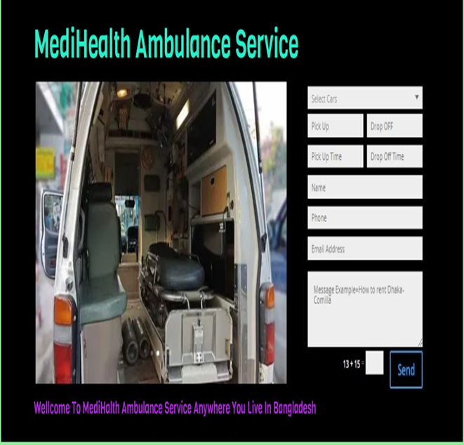

Figure 14: Ambulance Service Page

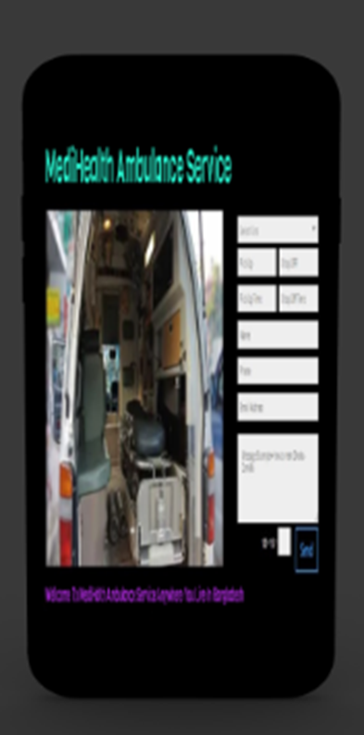

Figure 15: Ambulance Service Page (Mobile Version)

### 4.6 Mockup Testing Review

### 

### Forms response chart. Question title: Quality of product/service. Number of responses: 8 responses.

### Forms response chart. Question title: Customer support availability. Number of responses: 8 responses.

### Forms response chart. Question title: Features of the product/service. Number of responses: 8 responses.

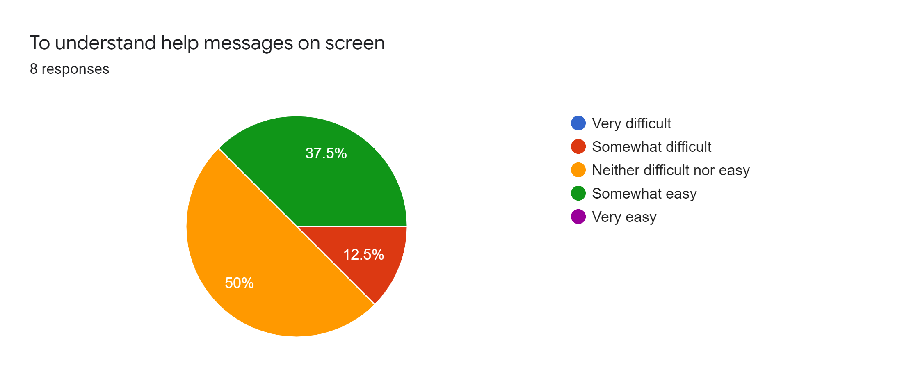

### Forms response chart. Question title: User Friendliness of the product/service. Number of responses: 8 responses.

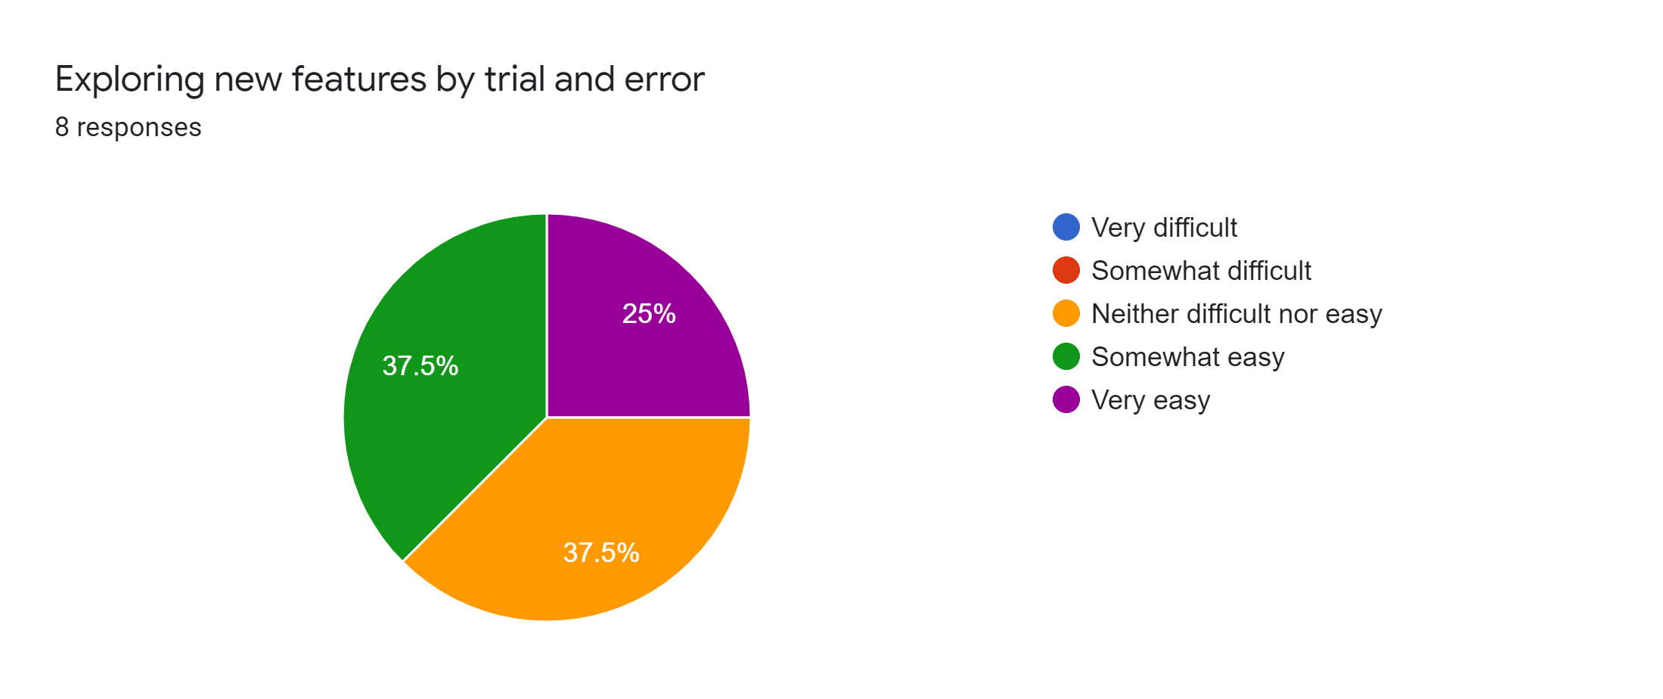

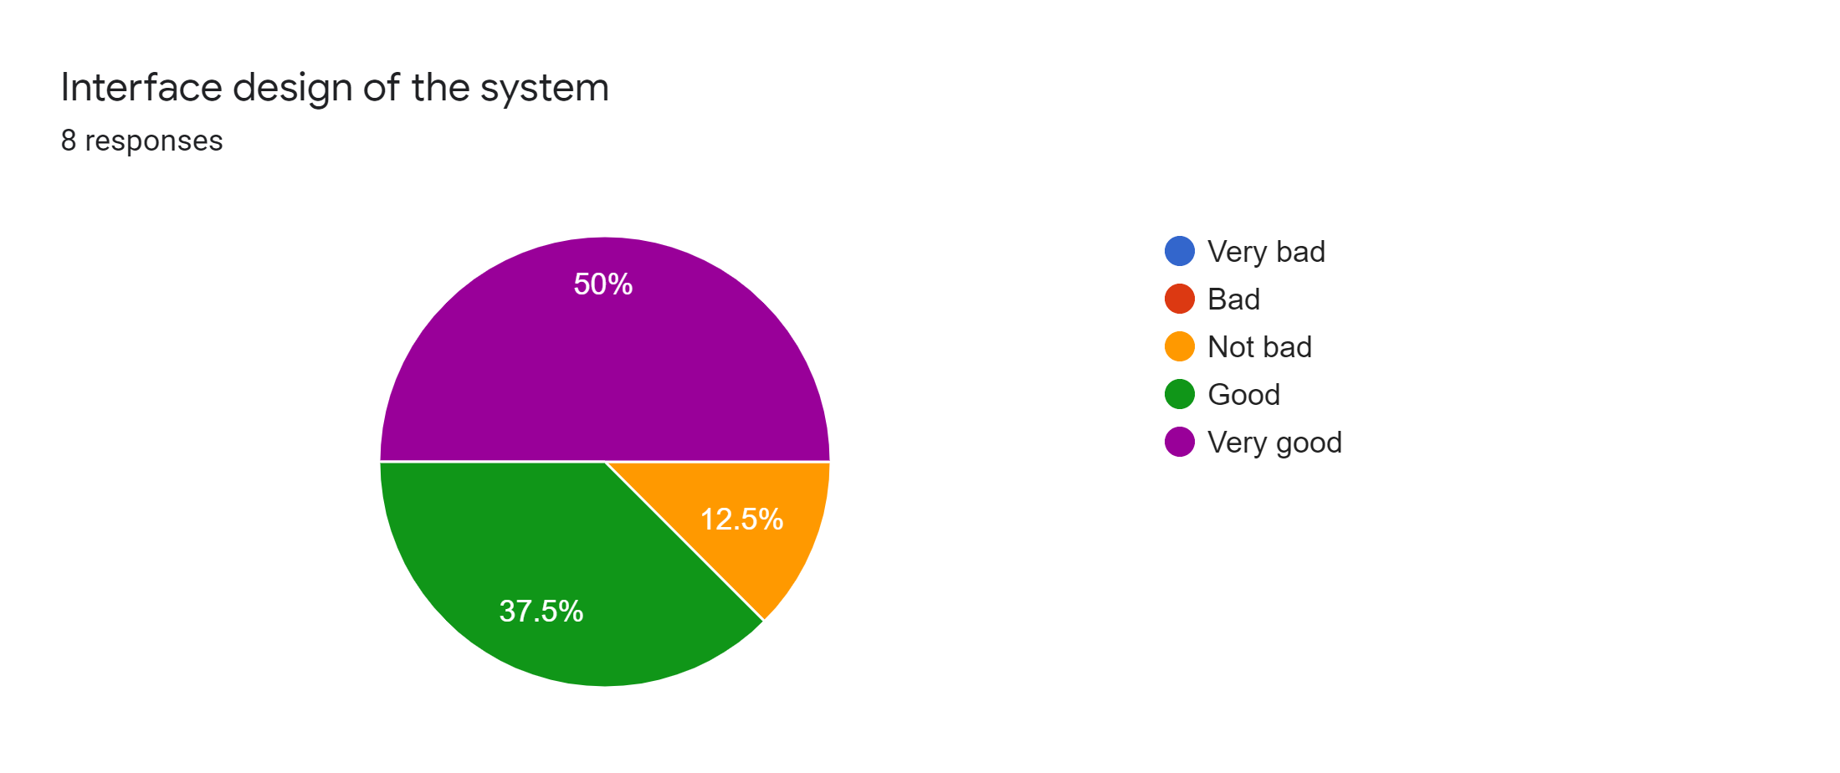

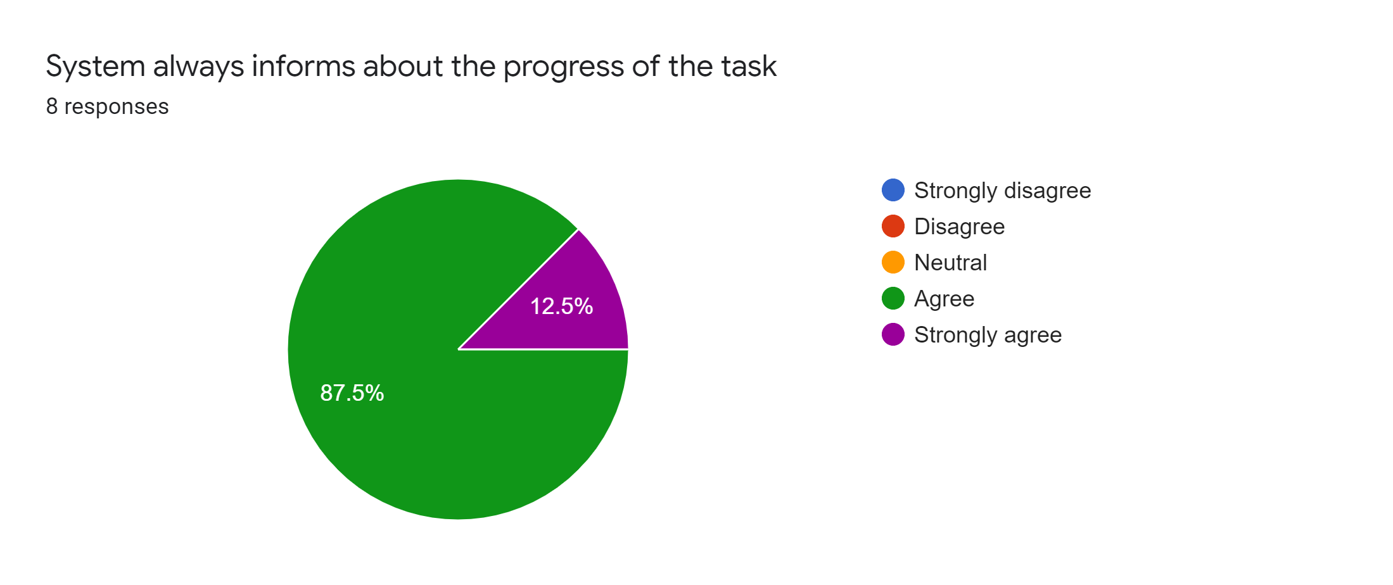

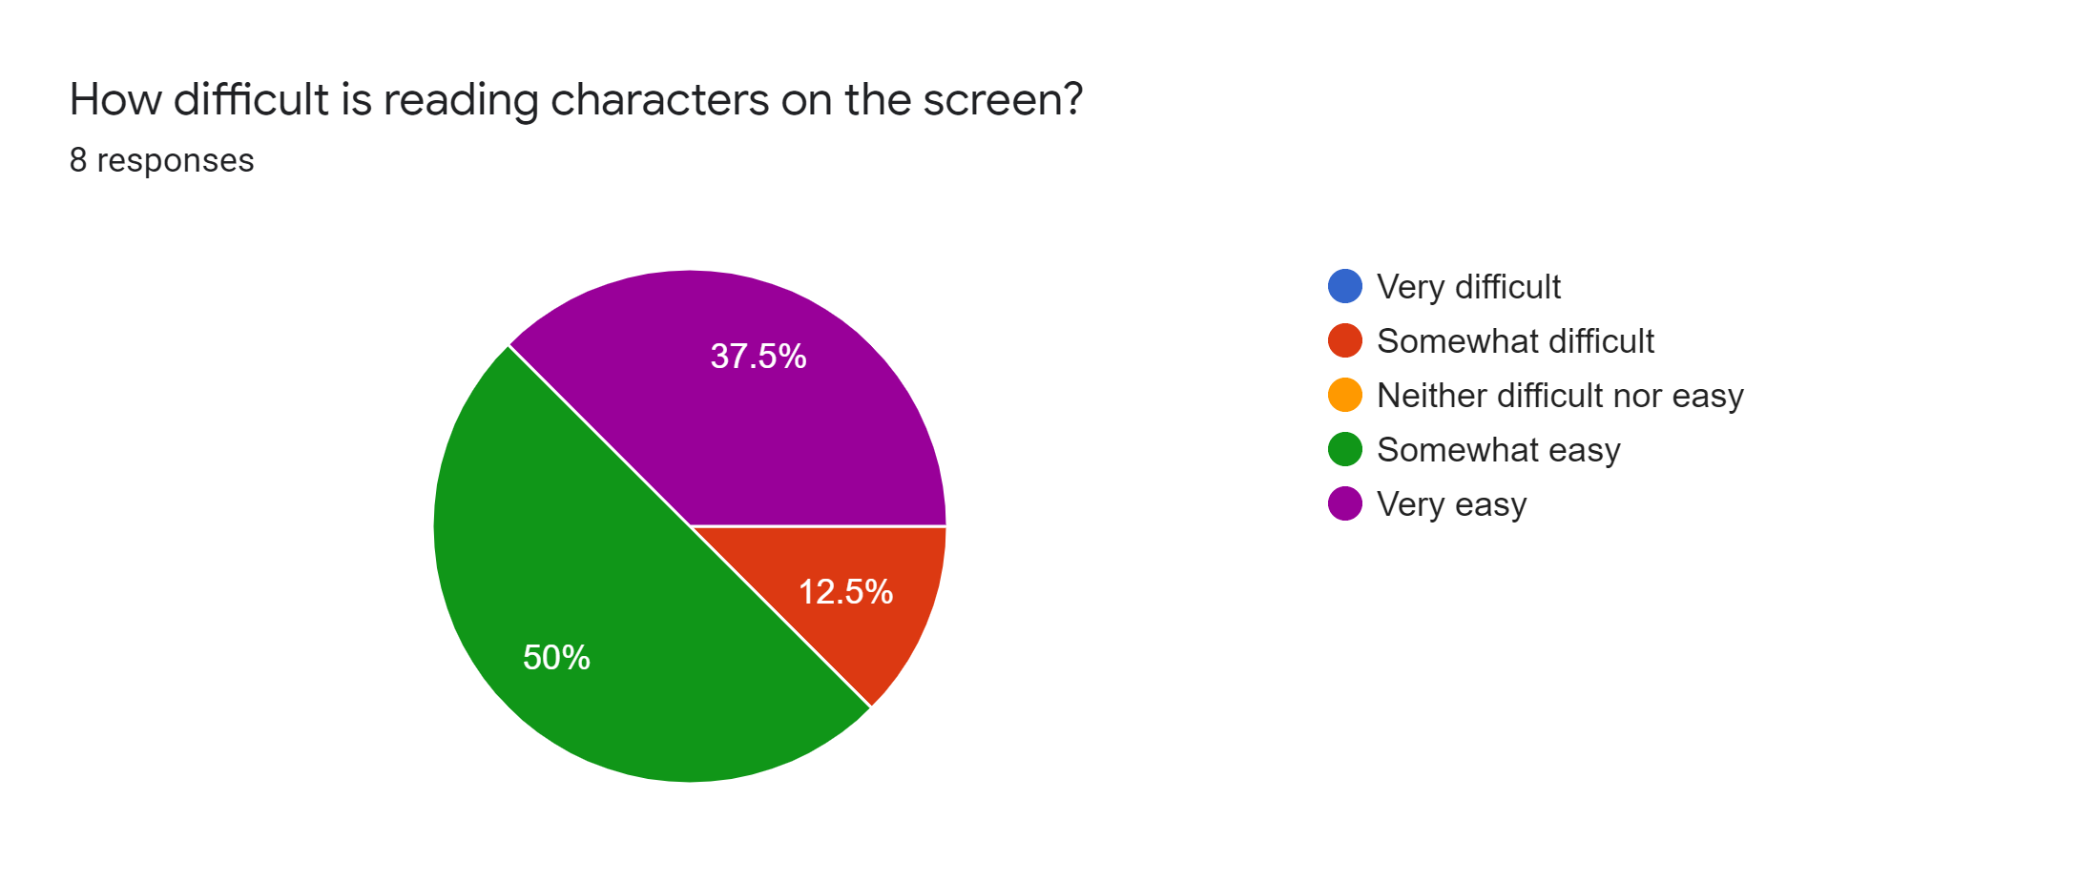

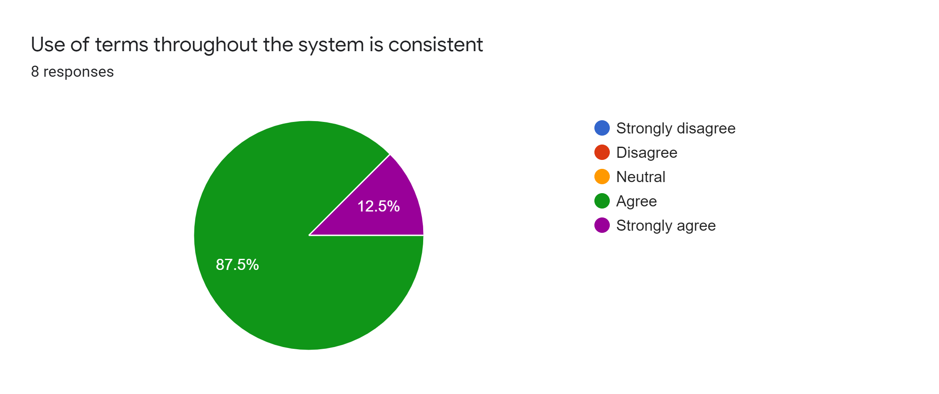

# 

# CHAPTER 5

## REQUIREMENTS VALIDATION

### 5.1 Formal review (inspection process)

In this project, a formal review will be done as a high-level process. In this process four of the project members will be participating and everyone has their individual role and group task. The Moderator of our project will act as the organizer who will keep everyone on task. He will control the pace of the review and act as an arbiter of disputes. There will be a reviewer who will be assigned to critical analysis. On the other hand in this inspection process, a reader will be looking at the source code to present this to the group. The data will not be critical in this process. This will separate what the author intended to do and what is the actual outcome. That's how the defects will come out. All the defects found in the source code will be recorded in detail including the location of the error in the code, wrong pseudo-code, documentation, data usage, developers error, designing oversight, and requirements mistake. All of this information will be kept in a database so deformity measurements can be examined from numerous points and perhaps contrasted with comparative measurements from QA. The diagram below shows the process of the formal review (inspection process) in short.

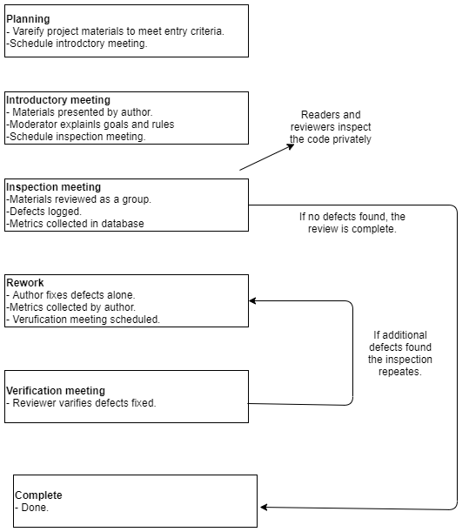

Figure 16: Overview of the inspection process.

# CHAPTER 6

## SOFTWARE PROJECT MANAGEMENT PLAN

### 6.1 Project Estimation

In this project Constructive Cost Model (COCOMO) will be used for calculation estimation. Our system is Complete software no hardware required. so, it is an organic project and the calculations are as follows:

Coefficient:= **2.4**

Project complexity **P = 1.05**

SLOC dependent coefficient **T = 0.38**

Source line of code (guessed) **SLOC =** 10000

**Effort Estimation formulas**

Effort = PM = Coefficient * (SLOC/1000) ^P Development Time = DM = 2.50 * (PM) ^T Required number of people = ST = PM/DM

using these formulas we get,

**Effort** = PM = 2.4 * (12000/1000) ^1.05 = **32.61** person-days needed for the project (labor working hours) check whether it is PM or person days

**Development Time** = DM = 2.50 * (**32.61**) ^0.38 = **9.398** Weeks (week-days)

**Required number of people** = ST = **32.61** /**9.398** = **3.47 ≡ 4**

**Cost:**

Labour cost : 3 * 40118.33 = 120355/= BDT (Approximately)

Service cost = 17000/= BDT (Approximately)

Total cost = 137355/= BDT(Approximately) or $1717 (Approximately)

**6.2 Project Budgeting**

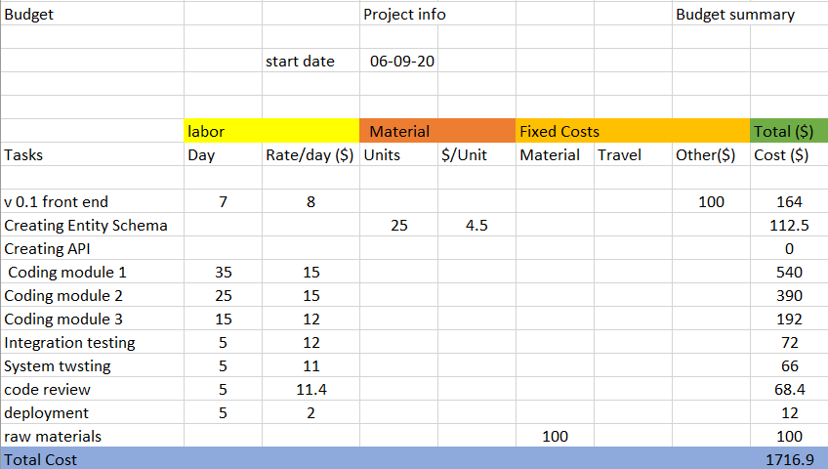

Fig 17: Budget for **Online marketplace for pharmacy and emergency ambulance service providers** system.

### 6.3 Project Scheduling

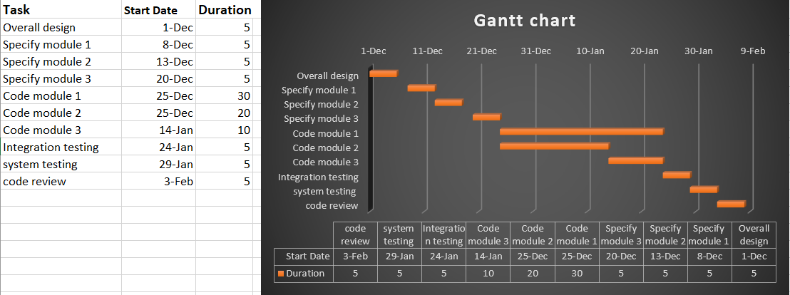

Figure 18: Activity plan for **Online marketplace for pharmacy and emergency ambulance service providers** system.

**labor responsibilities:**

A: Overall design B: Code module 1 D: System testing

A: Specify module 1 B & C: Code module 2 A: Code review

A: Specify module 2 C: Code module 3

A: Specify module 3 D: integration testing

### 6.4. Risk Assessment

Major Risk components that have the possibility to appear in our project.

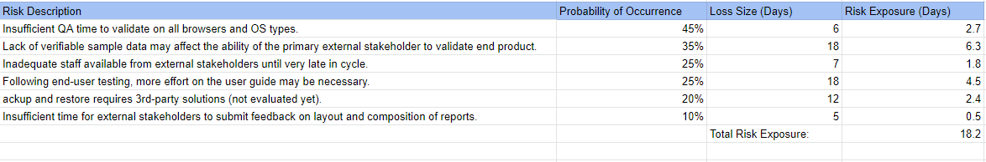

Figure 19: Risk factors of my **Online marketplace for pharmacy and emergency ambulance service providers** system.

We can reduce this type of risk by following the risk plan.

Risk prevention/avoidance – If we need more time then we can increase our duration estimation or we can reduce some functionality for the next increment.

**Risk reduction** – some risks, while they cannot be prevented, can have their likelihood reduced by prior planning. The risk of late changes to a requirements specification can, for example, be reduced by prototyping but will not eliminate the risk of late changes. We are following an incremental model so for further improvement and the modules that have the possibility for risk, we will reserve them for the next increment. This will reduce some possible risks.

Risk is the possibility that our project plan can go wrong. So, it is quite impossible to predict all of the risks in a project. But these precautions can reduce most of the risks.

# CHAPTER 7

## CONCLUSION & REFERENCES

### 7.1 Conclusion

### 

This research serves to design and develop a system tool for users to understand and utilize our system to compare and order medicine from different shopkeepers at different rates so, the users can be informed and make a purchase from the retailer they choose and also there is an emergency button which will alert the ambulances around the area to arrive at the user’s location in case of emergency which might help to reduce the number of deaths of not being able to reach the hospital on time. The project takes a participatory design approach, wherein all the stakeholders that the system is designed to help contribute to the design process. This approach helps us to design a system where people would find from navigating through the website to purchasing or using the emergency services to be as easy and seamless as possible which will not only benefit young people but also old people who can easily order the medicines from the comfort of their homes.

### 7.2 References:

●[**https://sci-hub.st/https://link.springer.com/article/10.1023/A:1021009212905**](https://sci-hub.st/https:/link.springer.com/article/10.1023/A:1021009212905)

●[**https://sci-hub.st/https://onlinelibrary.wiley.com/doi/abs/10.1111/j.1477-4658.2007.00460.x**](https://sci-hub.st/https:/onlinelibrary.wiley.com/doi/abs/10.1111/j.1477-4658.2007.00460.x)

● [**https://sci-hub.st/https://link.springer.com/article/10.1057/jcb.2011.19**](https://sci-hub.st/https:/link.springer.com/article/10.1057/jcb.2011.19)

● [**https://sci-hub.st/https://repositorio.iscte-iul.pt/handle/10071/15191**](https://sci-hub.st/https:/repositorio.iscte-iul.pt/handle/10071/15191)

● [**https://sci-hub.st/https://www.jstor.org/stable/10.2979/esj.2003.2.3.71**](https://sci-hub.st/https:/www.jstor.org/stable/10.2979/esj.2003.2.3.71)

●[**https://sci-hub.st/https://www.tandfonline.com/doi/abs/10.1300/J115v21n03_03**](https://sci-hub.st/https:/www.tandfonline.com/doi/abs/10.1300/J115v21n03_03)

●[**https://scihub.st/https://www.sciencedirect.com/science/article/pii/S1544319115303113**](https://scihub.st/https:/www.sciencedirect.com/science/article/pii/S1544319115303113)